User Manual for Agile Board

Login/Logout

To login to the Agile Board system, please use the USC CSE system NetID and password. This module is the same for both users and admins and based on your credentials it will direct you to the relevant part of the system.

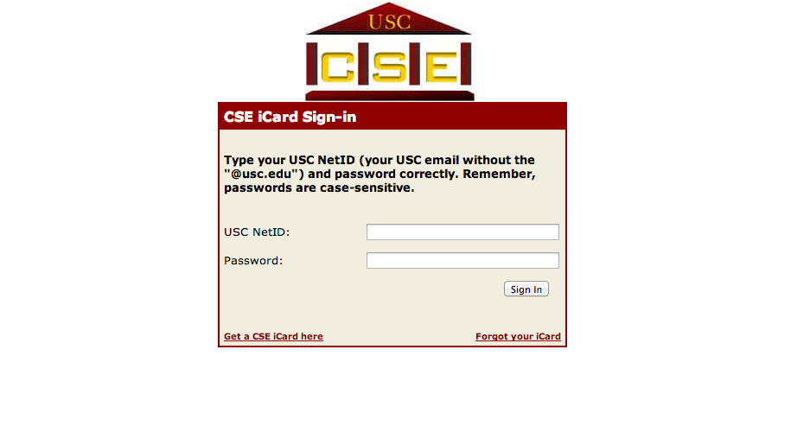
To logout from the system, just click the logout button on the top right.

Users

View Board

As soon as you login to the system as a user, you will be directed to this page. This will be the home page of any user.

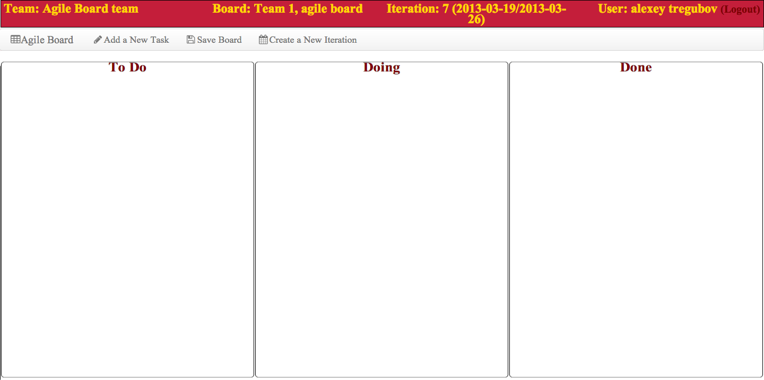

Note: If you are a user and you do not see your team’s board when you login, contact your administrator and asked to be added to the team you belong to.

Add a New Task

To add a new task follow these steps:

- From the toolbar above the agile board, click Add a New Item.

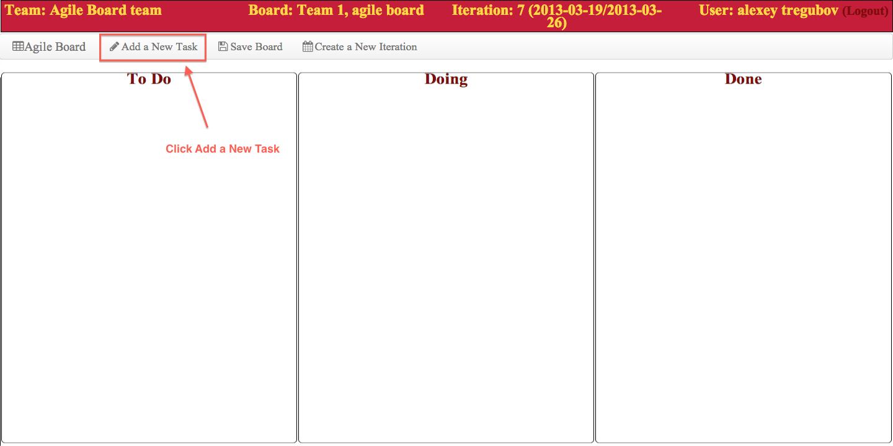

- When you see the newly created task (Screenshot A), edit the necessary fields (Screenshot B)

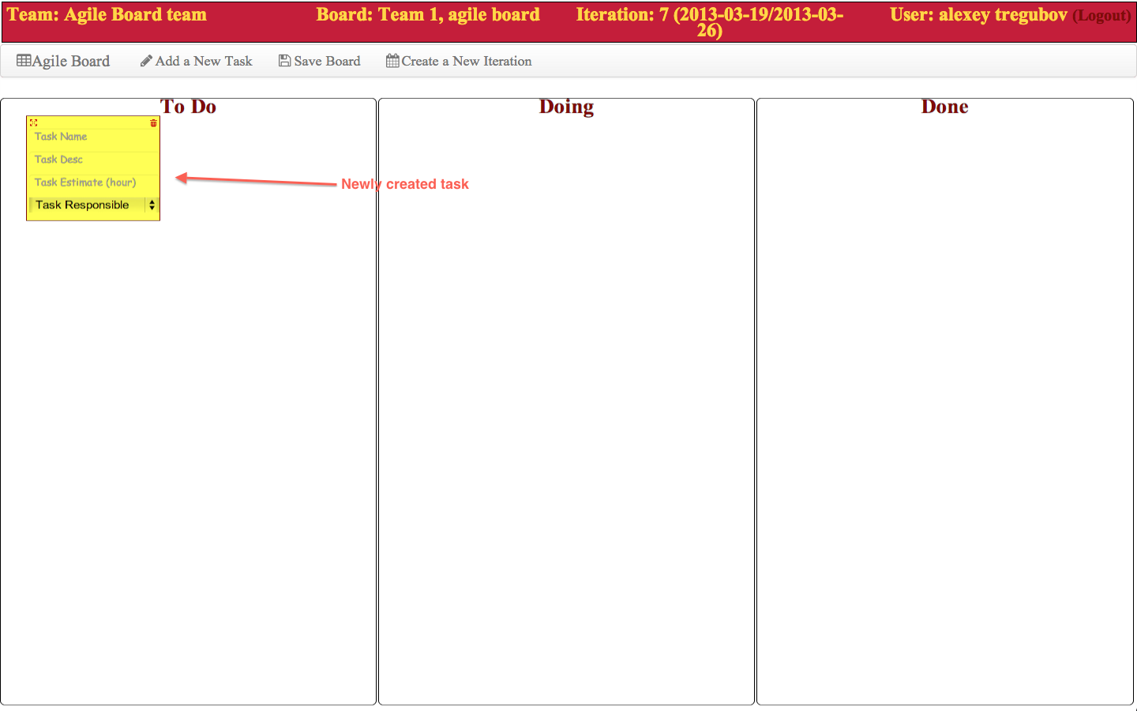
Screenshot A

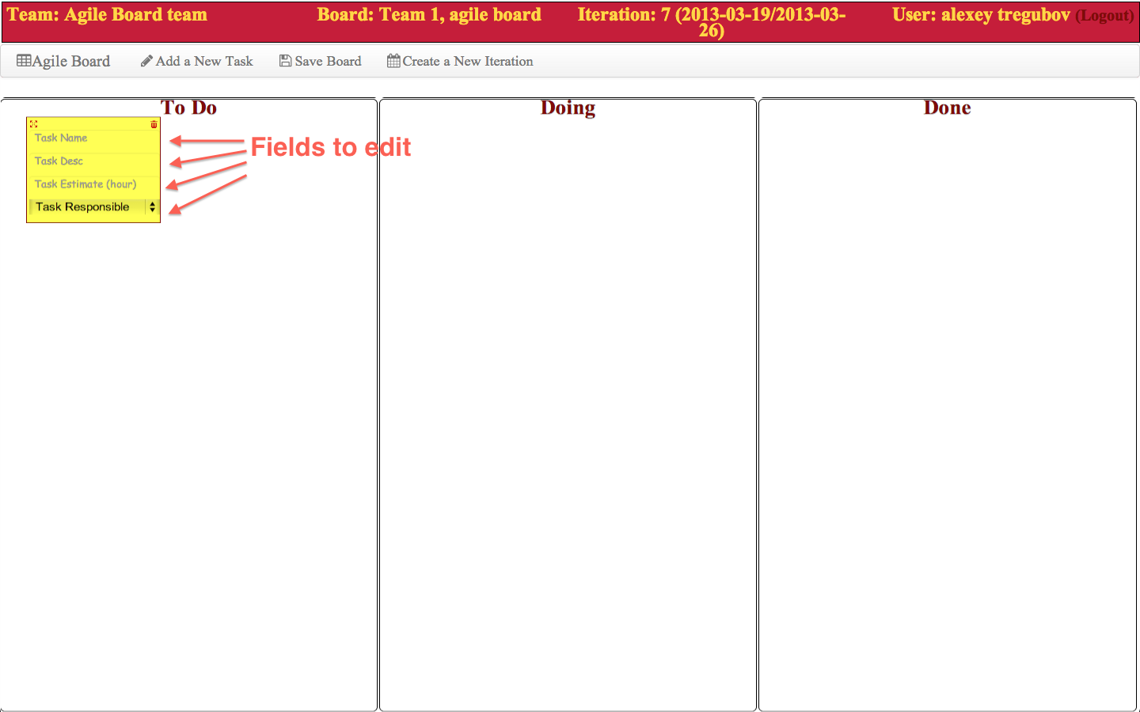
Screenshot B

- After you edit the the fields, click Save Board to update the board for the team.

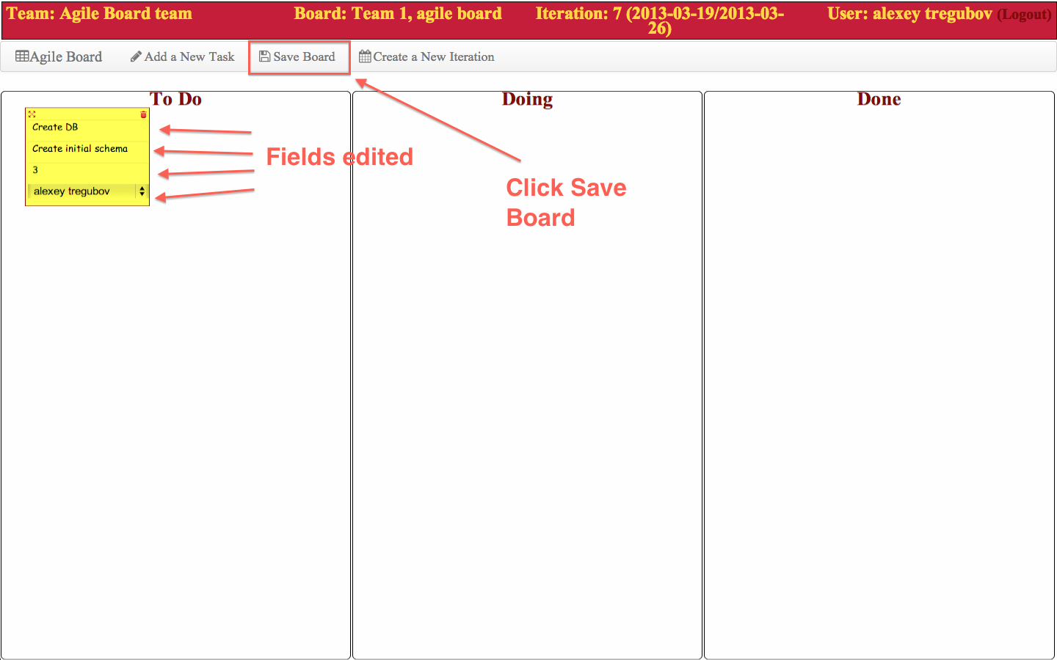

Create a New Iteration

To create a new iteration follow these steps:

- From the toolbar above the agile board, click Create a New Iteration.

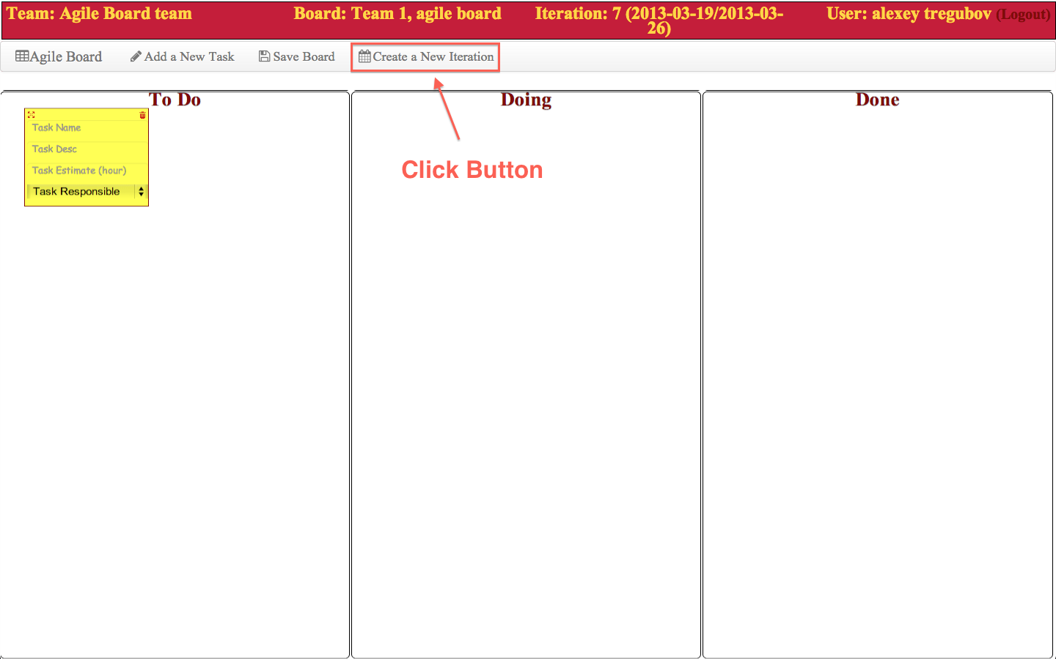

- The Create a New Iteration page will give you options for the iteration number, and dates.
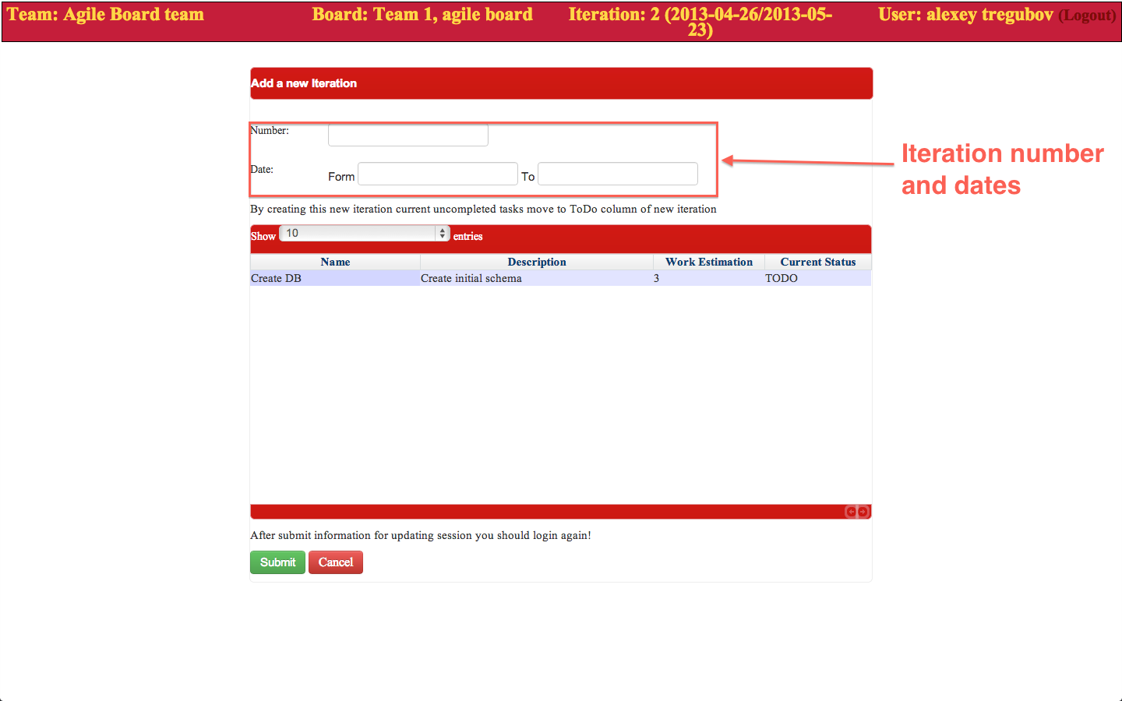

- The incomplete tasks will be visible in the table below, like the task we created earlier.

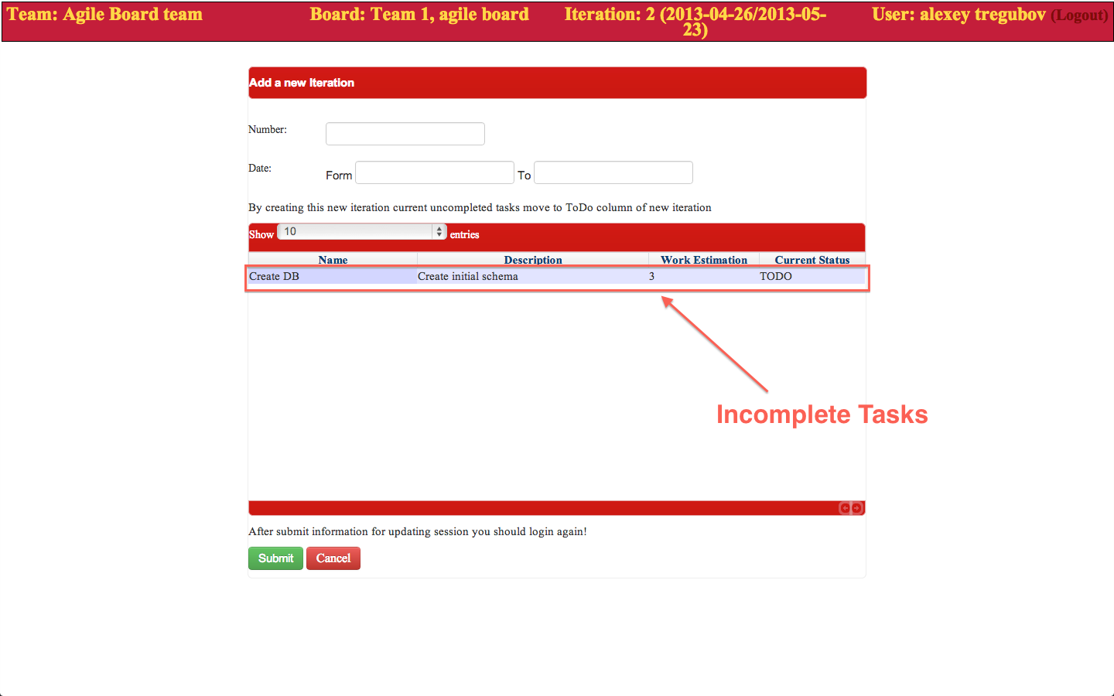
These tasks will be transferred to the newly created iteration.
- After you fill all the fields just click submit.

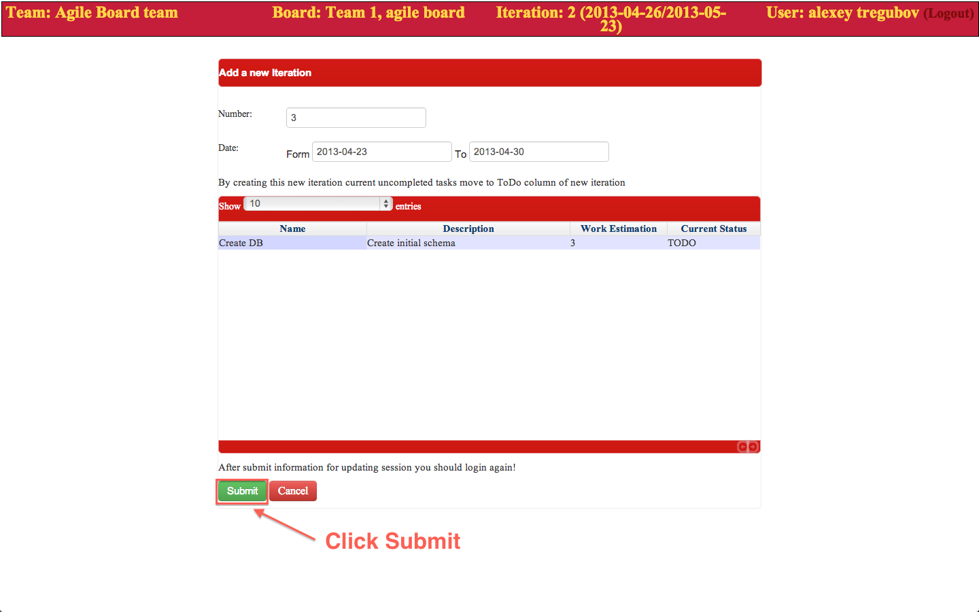
5. Once you click submit, make sure to logout and log back in to see the changes.

Moving Tasks

To move tasks from one column to another is really easy. Just click and hold the arrows on the top left corner of any task, drag and drop to the column you want.

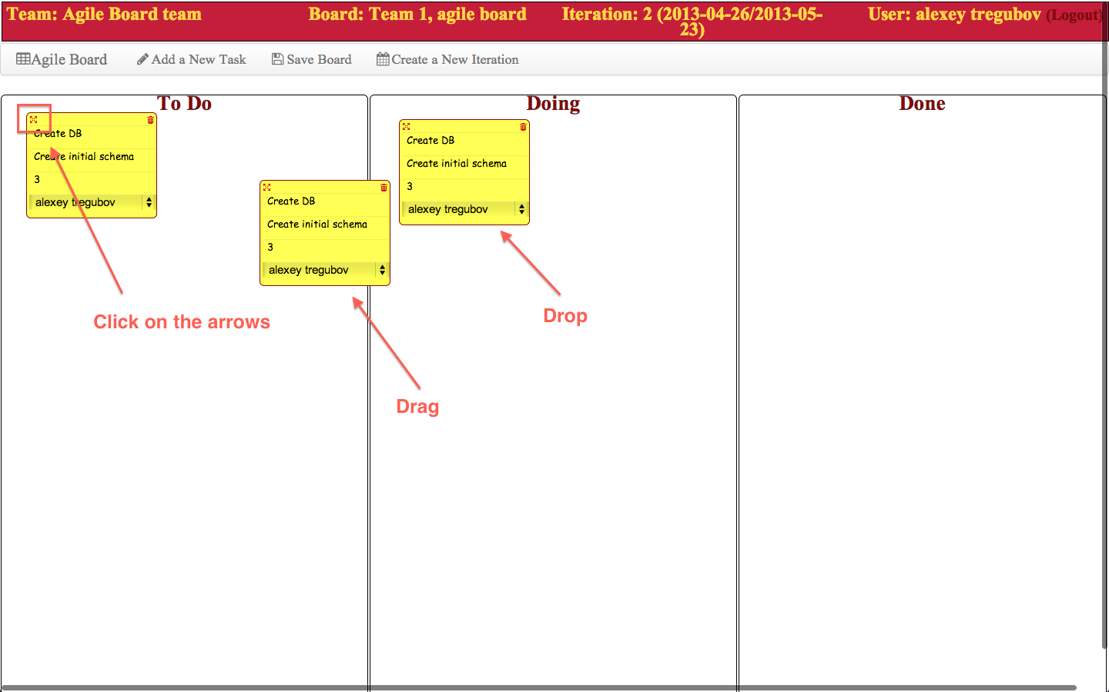

Deleting Tasks

To delete a task simply click the trash button at the upper right corner of any task.

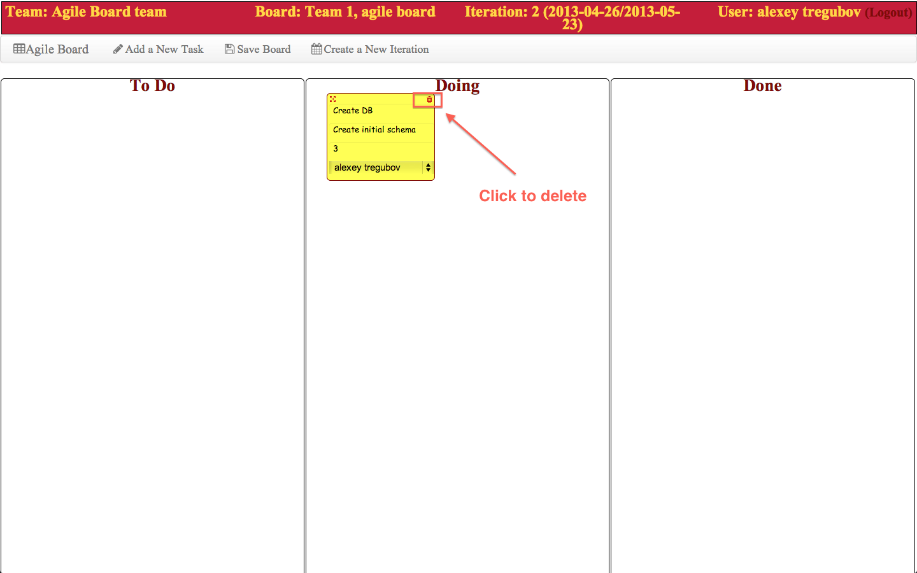

Note: Be careful with this function. There is no undo functionality.

